History
Banner image

A brief history of the park
by Kevin Earl
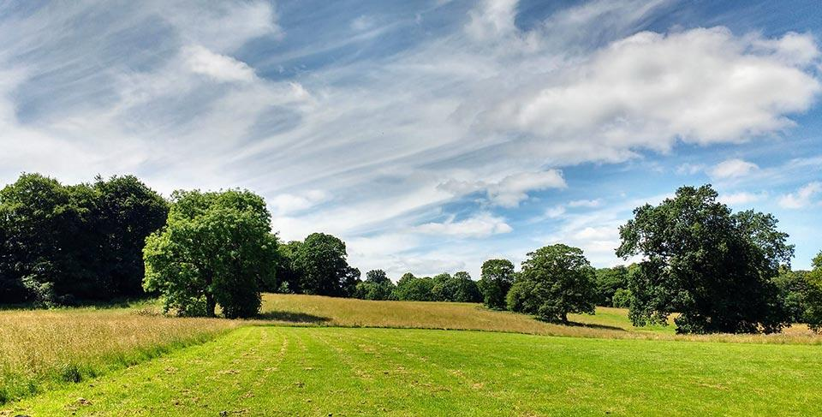
A research study has revealed that Jacob Smith Park holds significant local archaeological importance and is a relic of a much older landscape associated with the village of Scriven.

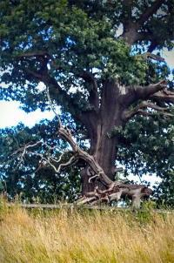

The Claro Community Archaeology Group, based in Knaresborough, undertook the research study and the findings were published in 2013 in a fascinating book called The Chronicles Of Scriven.
Some of the trees in Jacob Smith Park are likely to be around 400 years old, and Low Wood at the western edge of the park was planted as part of the landscaping of the estate by the Slingsby family in the 18th Century. Having landscaped their fields, the Slingsbys then enclosed their new parkland by building the impressive estate wall, which still runs along Scriven Road and Scotch George Lane. The Slingsbys resided at Scriven Hall, which overlooked the park and was demolished in 1954 after a fire.
Guiseley Hill, at the very top of the park, is the possible site of an Iron Age settlement with the remains of a bank and ditch. There is also some evidence of hut circles within an enclosure. Like all other archaeological remains within the park, there has been no excavation work undertaken and the ground is still undisturbed.

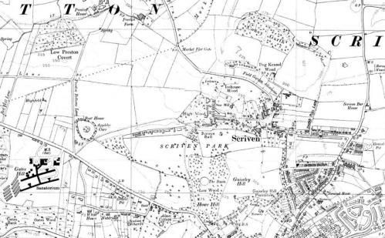

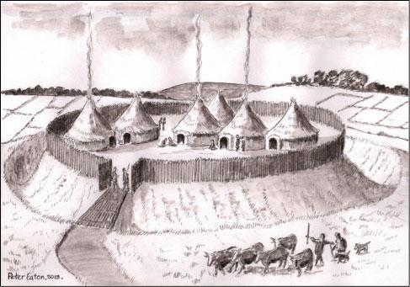

Iron age settlement
credit Chronicles of Scriven

There is some ridge and furrow, which is evidence of medieval farming, and this is still visible when the grass is short. A map dated 1629 shows that a farmstead once stood in the park, next to Scotch George Lane. The ponds within the park may be associated with small-scale iron smelting in the 16th-17th centuries and there is evidence of a water management system in the fields; again no detailed investigations have yet been undertaken.
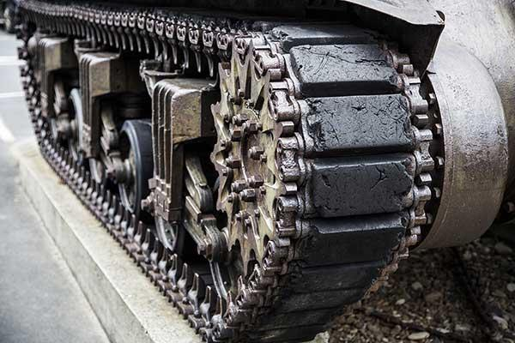

In more recent times, the park was used to train tank crews and infantry during World War Two when Scriven Hall was requisitioned as an army camp.
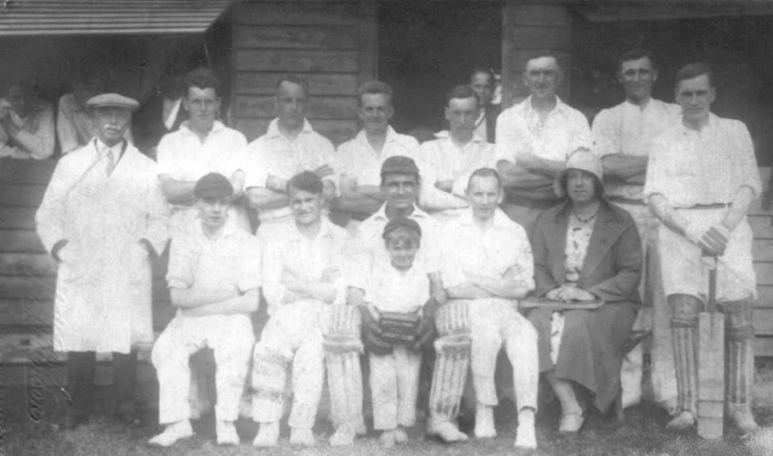
The park also served as the village cricket pitch.
A gift to the community

Throughout every season, Jacob Smith Park offers up its treasures for us to share and enjoy. We will be forever grateful as a community to Winifred Jacob Smith MBE for her wonderful bequest which in her own words is
“For people to enjoy the freedom and the beauty that public parks bring.”

After Scriven Park was sold by the Slingsby family in 1955-56, sisters Winifred and Dorothy Jacob Smith bought the 30 acres of parkland, which later became home to their Ayrshire cattle.

